Link de Video

https://drive.google.com/file/d/1jLZEhTOIxPH7hyoYWvm7ModrH-UHJB-T/view?usp=sharing

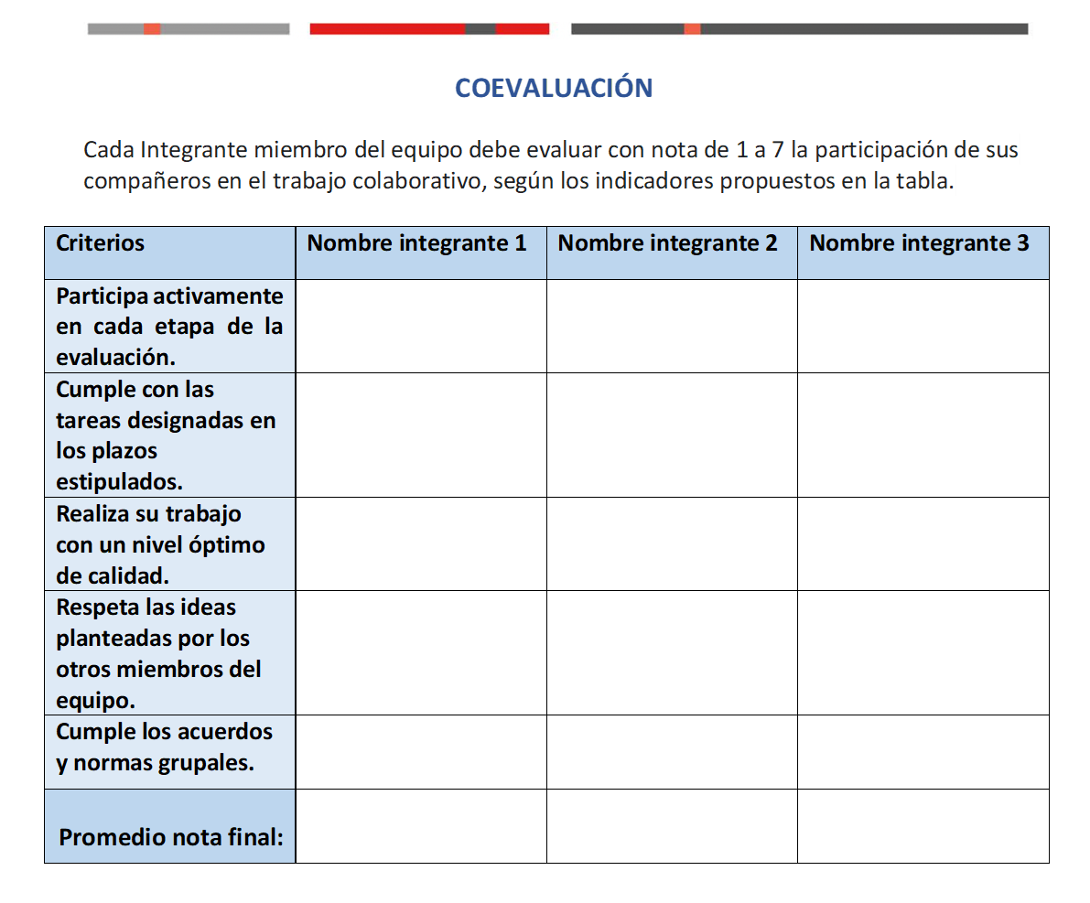
Jaime
Velásquez

7

7

7

7

7

7

Cristóbal

Araya

7

7

7

7

7

7

Benjamín

Jara

7

7

7

7

7

7

